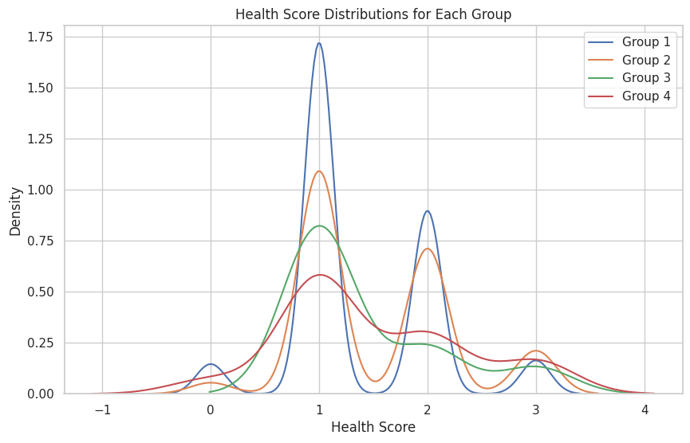

To verify if the health scores are related to hiring discrimination ('disc_hire') and whether groups 1 and 3 (no discrimination or predicted no discrimination) have similar distributions, which are different from groups 2 and 4 (discrimination or predicted discrimination), you can use statistical tests to compare these distributions. The approach involves two main steps:

1. **Comparing Groups 1 and 3 vs. Groups 2 and 4**:
   * This comparison checks if the distributions of health scores in groups experiencing no discrimination (actual or predicted) are different from those experiencing discrimination.
   * You can use a non-parametric test like the Mann-Whitney U test for this comparison since it does not assume normality.
2. **Assessing the Similarity within Group Pairs**:
   * To verify the similarity within pairs (Group 1 vs. Group 3 and Group 2 vs. Group 4), you can again use a non-parametric test.
   * The null hypothesis for each test would be that there is no significant difference between the distributions of the two compared groups.

Let's start by comparing groups 1 and 3 against groups 2 and 4 using the Mann-Whitney U test. Then, we'll proceed to compare within the pairs (Group 1 vs. Group 3 and Group 2 vs. Group 4).

The results of the Mann-Whitney U tests provide valuable insights:

1. **Groups 1 and 3 vs. Groups 2 and 4**:
   * Mann-Whitney U statistic: 947548.0
   * p-value: approximately 8.31×10−78.31×10−7
   * This very small p-value suggests a significant difference between the combined distributions of groups 1 and 3 (no discrimination or predicted no discrimination) and groups 2 and 4 (discrimination or predicted discrimination). This indicates that health scores are indeed related to the experience of hiring discrimination.
2. **Group 1 vs. Group 3**:
   * Mann-Whitney U statistic: 50225.0
   * p-value: approximately 0.991
   * The high p-value suggests no significant difference in the health score distributions between Group 1 (no discrimination) and Group 3 (predicted no discrimination).
3. **Group 2 vs. Group 4**:
   * Mann-Whitney U statistic: 21615.0
   * p-value: approximately 0.635
   * Similarly, this high p-value indicates no significant difference between Group 2 (discrimination) and Group 4 (predicted discrimination).

In summary, these results support your hypothesis: Groups 1 and 3 (not experiencing discrimination) have similar health score distributions, and these are significantly different from the distributions in Groups 2 and 4 (experiencing discrimination). The distributions within each pair (1 vs. 3 and 2 vs. 4) are not significantly different from each other, suggesting a consistent pattern related to the experience of hiring discrimination.